p5.js Canvas Coordinates Worksheet

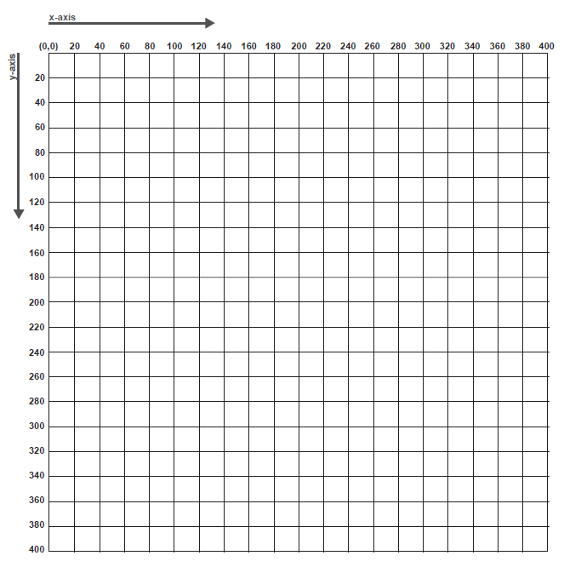

**Pseudocode:** What are the parameters for the shapes you are using?

|  |
| --- |